AR/VR ASSIGNMENT 2

The goal of this project was to create a realistic rotating Earth model using A-Frame and WebXR concepts. The project demonstrates Earth’s axial tilt and continuous rotation using 3D visualization techniques.
Task:
I created a 3D Earth visualization using A-Frame. A realistic Earth texture was applied to a sphere to represent the globe. The Earth continuously rotates on its axis using animation properties.
To simulate the Earth’s real axial tilt, I tilted the globe by 23.5 degrees using a parent <a-entity> and then applied rotation separately using a child <a-sphere>. This parent-child structure allows the Earth to rotate naturally while maintaining the tilt angle.
The application also includes:
- Earth texture mapping
- Axial tilt implementation
- Continuous Earth rotation
- Lighting for realistic appearance
- WebXR-compatible 3D environment
The scene was designed with lighting and supporting objects to improve the visual realism of the Earth model.

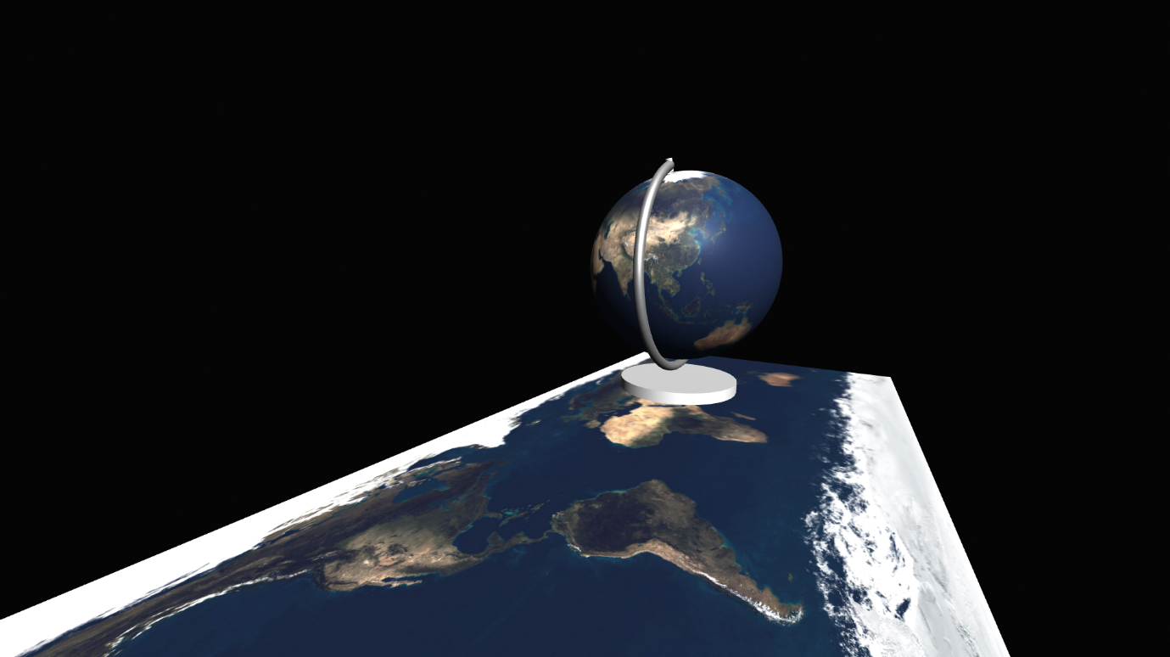
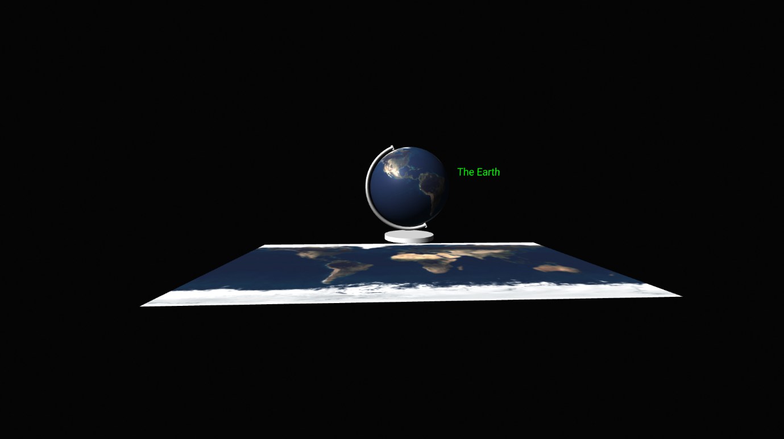

Technologies Used:
- HTML
- CSS
- JavaScript
- A-Frame
- WebXR
Conclusion
This project successfully demonstrates a realistic rotating Earth model using A-Frame and WebXR concepts. The Earth rotates continuously on a tilted axis, accurately simulating Earth’s axial tilt and rotational movement in a 3D environment.

